
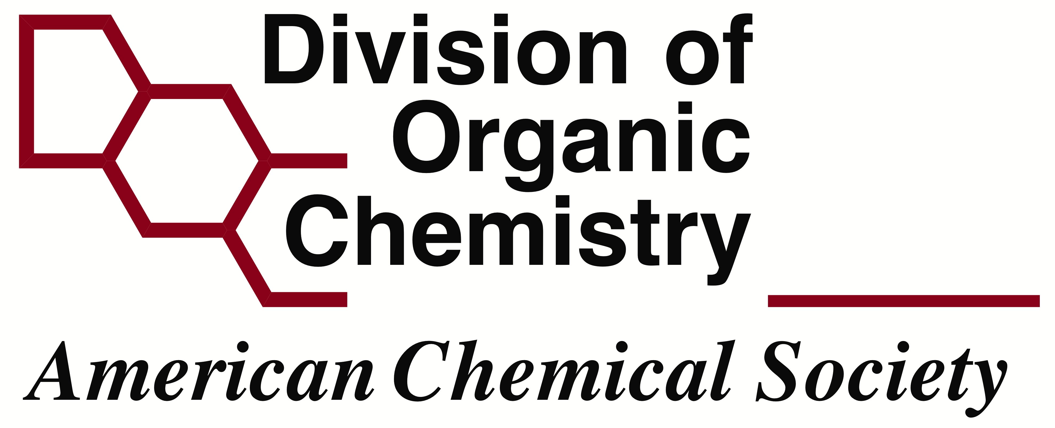
American Chemical Society
DIVISION OF ORGANIC CHEMISTRY
GRADUATE RESEARCH Symposium APPLICATION
APPLICANT INFORMATION
First Name and Middle Name or Initial:
Last Name:
Mailing Address:

e-mail address:
American Chemical Society Membership Number:
Ph.D. University:
Year you began your Ph.D. Program:
Research Advisor:
Graduate GPA (lecture classes only):
Tentative Thesis Title:
Undergraduate Institution:
Undergraduate Major and Degree earned:
Undergraduate GPA:
Honors/Awards/Fellowships (undergraduate and graduate):

Other relevant research experience:

Teaching experience:

PUBLICATIONS (published, in press or accepted ONLY. List all authors, include titles and full journal citations)

OTHER PUBLICATIONS (submitted or in preparation. List all authors, include titles and targeted journal)

POSTERS OR PRESENTATIONS AT MEETINGS OR CONFERENCES

NAME AND CONTACT INFORMATION OF RECOMMENDATION LETTER AUTHOR

SUMMARY OF GRADUATE RESEARCH (2-4 pages, please use graphics where appropriate and DO-NOT exceed the page limit.)

